**Registration System 1.0**

**Professor User Documentation**

**2016**

**NOTE: If you do not yet have an account you must create one. To do so you must visit the login page and click the “registration” link. The administrator will notify you when the account has been activated.**

**Navigation**

As a professor you may teach courses and view student lists. At the top of the app you have the following options you may select:



*Course listing* shows you all the courses currently offered*.*

*Courses I can Teach* shows you the courses from your department that you may teach

*Courses I’m Teaching* shows you courses that you are currently teaching*.*

*Profile* shows you basic information about your profile

*Logout* will log you out of the application.

**Teaching a Course**

You may teach a new course by selecting a course under “Course Listings”:

1. Select the course you want to teach by selecting the checkbox next to the course listing:



2. Click the submit button at the bottom of the application:



**Stop Teaching a Course**

You may stop teaching a course under “Courses I’m Teaching”.

1. Select the course you wish to no longer teach by selecting the checkbox next to the course listing:



2. Click the submit button at the bottom of the page:



**Viewing Courses**

“All Courses” and “Courses I’m Teaching” sections show you basic information about the course. Under each section you may view more details by clicking the name of the course. For example, under “All Courses” you will see listings similar to the below picture:

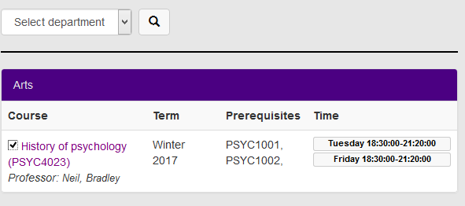

Clicking on the “History of Psychology (PSYC4023)” will show you more information about the course:

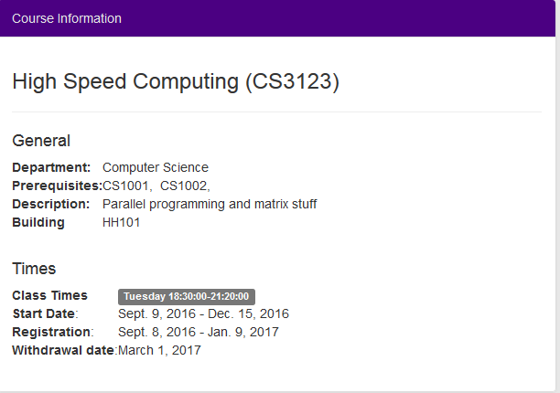

You may search for courses by course id, category, or both. The below diagram shows the search feature:

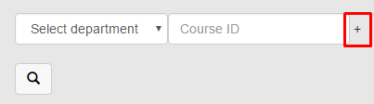

Notice the marked “+” sign in red. Clicking this icon will add an additional search filter.